Calming Wheel
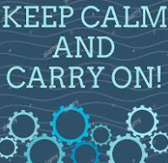
​
This technique is a very useful quick technique to manage the physical sensation of anxiety and panic in the chest/tummy.
Imagine a red wheel turning up through your tummy out through your chest, round and round.
Now make the wheel a calming colour, such as blue and make the wheel stop and turn the other way.
You will instantly feel that feeling in your chest reduce.

