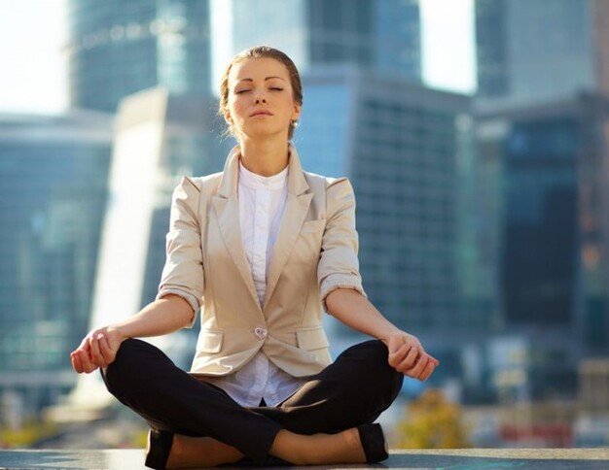
Calming breathing

Doing this simple exercise increases calm and reduces anxiety/stress.

Practice as often as you can. It only takes a few moments and the more your practise the greater the benefit. Bedtime is always a good time to practice.
1. close mouth
(we tend to breathe faster through our mouth, only exacerbating unpleasant feelings/sensations)
2. breath in slowly
(visualise soft gentle calm flowing in and down your body)
3. breath out slowly
(visualise tension leaving your nose and body and notice your shoulders relax down)

4. repeat 2-3, ten times, counting (in your mind) at the end of each out breath.

You can leave the practice there or continue counting breaths from 1 to 10 repeatedly, to deepen relaxation.
Note: If your mind wonders off, just keep re-focusing on your breath. We can't stop our thoughts, but we can choose what we focus on.
www.veritygoodfellow.co.uk

